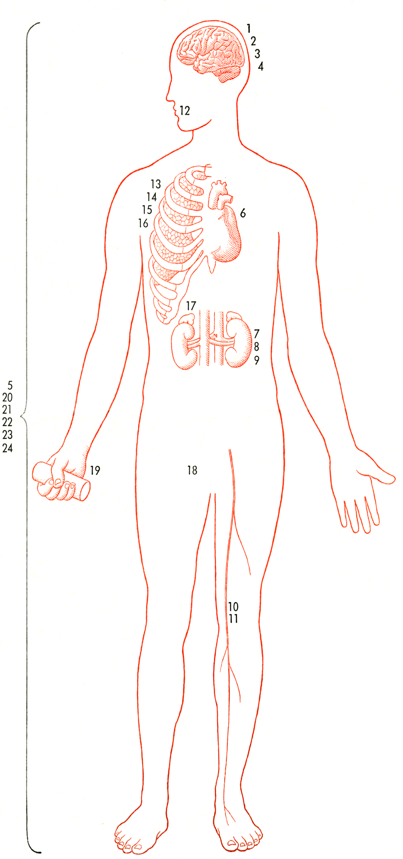
APPLYING
BIOMECHANICS
TO AGED

J. David Skliar, DPM

PHYSIOLOGICAL DECLINE ACCOMPANYING AGE. Changes are great in some cases, small in others. The figures in brackets following most of the labels in the key are the approximate percentages of functions or tissues remaining to the average 75-year-old man, taking the value found for the average 30-year-old as 100%.

1 BRAIN WEIGHT [56]
2 MEMORY LOSSES
3 SLOWER SPEED OF RESPONSE
4 BLOOD FLOW TO THE BRAIN [80]
5 SPEED OF RETURN TO EQUILIBRIUM
OF BLOOD ACIDITY [17]
6 CARDIAC OUTPUT (AT REST) [701]
7 NUMBERS OF GLOMERULI IN
KIDNEY [56]
8 GLOMERULAR FILTRATION RATE [69]
9 KIDNEY PLASMA FLOW [50]
10 NUMBER OF NERVE TRUNK
FIBERS [63]
11 NERVE CONDUCTION VELOCITY [90]
12 NUMBER OF TASTE BUDS [36]
13 MAXIMUM OXYGEN UPTAKE
(DURING EXERCISE) [40]
14 MAXIMUM VENTILATION VOLUME
(DURING EXERCISE) [53]
15 MAXIMUM BREATHING CAPACITY
(VOLUNTARY) [43]
16 VITAL CAPACITY [56]
17 LESS ADRENAL ACTIVITY
18 LESS GONADAL ACTIVITY
19 HAND GRIP [55]
20 MAXIMUM WORK RATE [70]
21 MAXIMUM WORK RATE FOR SHORT
BURSTS [40]
22 BASAL METABOLIC RATE [84]
23 BASIC WATER CONTENT [82]
24 BODY WEIGHT FOR MALES [88]
.

